
SRM Institute of Science and Technology
SET B

College of Engineering and Technology
DEPARTMENT OF ECE
SRM Nagar, Kattankulathur – 603203, Chengalpattu District, Tamilnadu
Academic Year: 2022-2023 (ODD)
Test: CLAT- 2 Date: 11-10-2023
Course Code & Title: 18ECE340T – Machine Perception with Cognition Duration: 100 minutes
Year & Sem: IV/VII Max. Marks: 50
Course Articulation Matrix:
 | 18ECS301J – Applied Programming | PROGRAM OUTCOMES |  |  |  |  |  |  |  |  |  |  |  |  | PROGRAM STUDENT OUTCOMES
CO | COURSE OUTCOMES | 1 | 2 | 3 | 4 | 5 | 6 | 7 | 8 | 9 | 10 | 11 | 12 | 1 |  | 2 | 3
1 | Understand the fundamentals of image Processing, camera and color models | 3 | 2 | - | - | - | - | - | - | - | - | - | - | - |  | - | -
2 | Analyze the binary shapes, region and boundary- based image modeling | 3 | - | - | 2 | - | - | - | - | - | - | - | - | - |  | - | -
3 | Illustrate the various filter banks, shape and textures for image synthesis | - | - | - | 2 | - | - | - | - | - | - | - | 3 | - |  | - | -
4 | Express the objects, frames based on template relations | 3 | - | 2 | - | - | - | - | - | - | - | - | - | - |  | - | -
5 | Apply the concept of 2D and 3D face recognition | - | - | 3 | - | 2 | - | - | - | - | - | - | - | - |  | - | 1
6 | Implement the concept of image processing and machine vision in real time applications | 3 | 2 | - | - | - | - | - | - | - | - | - | - | 2 |  | - | -

Part – A (10 x 1 = 10 marks)
Answer all the Questions
Q. No | Question | Marks | BL | CO | PO
1 | Predict the output of the binary image after applying connected components operations.  a) Connected image c) labeled image  b) filtered image d) True image | 1 | 1 | 2 | 1
2 | Choose the formula for 8 –Connectedness  a) ds= max(│ xi+xj│,│yi-+yj│) b) ds=min(│ xi+xj│,│yi+yj│)  c) ds=max(│ xi-xj│,│yi-yj│) d) ds=min(│ xi-xj│,│yi-yj│) | 1 | 1 | 2 | 1
3 | The term POSE is often used to associate ______, _________ and _____  a) shape, location and orientation  b) size, shape and location  c) location, orientation and size  d) size, orientation and shape | 1 | 1 | 2 | 1
4 | The order of shape number for a closed boundary is:  a) Odd b) Even  c) 1 d) Any Positive Value | 1 | 1 | 2 | 1
5 | For pixels p(x, y), q(s, t), the Euclidean distance between p and q is defined as:  a) D (p, q) = [(x – s)2 + (y – t)2]1/2  b) D (p, q) = |x – s| + |y – t|  c) D (p, q) = max (|x – s| + |y – t|)  d)D (p, q) = [(x – s)2 + (y – t)2] | 1 | 2 | 2 | 1
6 | Compute the size of the co-occurrence matrix  a) 2Χ2 b) 3Χ3  c) 4Χ4 d)5Χ5 | 1 | 2 | 3 | 4
  0 | 1 | 2
  0 | 2 | 3
  3 | 4 | 1
7 | The ________ approach is based on studies of the statistics of pixel intensity distributions  a) Gray level co-occurrence matrix b) Local binary Pattern  c) Cross Correlation d)Auto correlation | 1 | 1 | 3 | 4
8 | The regular repetition of an element or pattern on a surface shows_______  a) Pixel b) Image  c) Feature d) Texture | 1 | 1 | 3 | 4
9 | The M₀₀ of the given 3 x 3 binary image is _______  a) 5 b) 7 c) 6 d) 3 | 1 | 2 | 3 | 4
  1 | 1 | 0
  1 | 0 | 1
  1 | 0 | 1
10 | Gaussian filter is a type of _____________ filter  a) Linear b) Nonlinear c) Spatial d) Spectral | 1 | 1 | 3 | 4
PART B
Section B1 (2x 4 = 8 marks)
Answer ANY 2 Questions
11 | With suitable example, define the regional descriptors based on Compactness and elongation. | 4 | 2 | 2 | 1
12 | Calculate the Centroid of the given binary image | 4 | 3 | 2 | 1
  1 | 1 | 1 | 0 | 0 | 1
  0 | 1 | 0 | 1 | 0 | 1
  0 | 1 | 1 | 0 | 1 | 0
  1 | 0 | 1 | 1 | 0 | 0
13 | Find the distance between two-pixels P (3,2) and Q (4,1) using city block distance measurement method  List out different types of texture representation. | 4 | 2 | 2 | 1
Section B2 ( 2x 4 = 8 marks)
Answer ANY 2 Questions
14 | Write short notes on: Texture synthesis of an image | 4 | 2 | 3 | 4
15 | Write an algorithm for LM filter bank | 4 | 2 | 3 | 4
16 | Compute the co-occurrence matrix for the following | 4 | 3 | 3 | 4
  0 | 0 | 1 | 1
  0 | 0 | 1 | 1
  0 | 2 | 2 | 2
  2 | 2 | 3 | 3
 | PART C (2 x 12 = 24 marks)
17 (a) | Explain the procedure to have skeleton image through thinning process with example. | 12 | 2 | 2 | 1
 | (or)
17 (b) | With suitable example, explain the boundary descriptors in detail | 12 | 2 | 2 | 1
18 (a) | Explain with relevant example how the Gaussian and Laplacian pyramid is applied to an image to obtain an sharpened and a smoothened image | 12 | 3 | 3 | 4
 | (or)
(b) | Determine the filtered image for the shaded portion using convolution process, given the 5 x 5 image and 3 x 3 mask  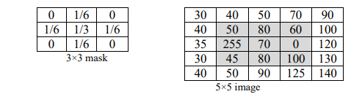 | 12 | 3 | 3 | 4
Course Outcome (CO) and Bloom’s level (BL) Coverage in Questions 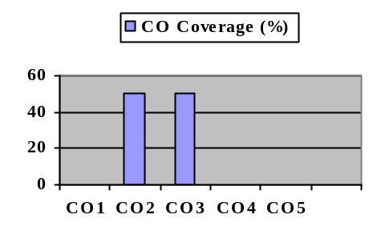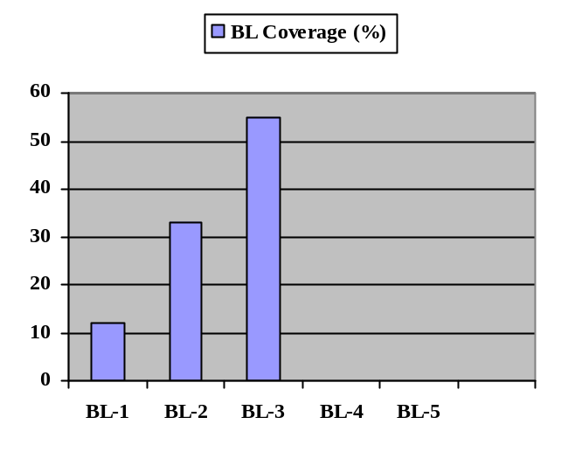

Evaluation Sheet

Name of the Student: Register No.:

Course Code and Title: 18EC340T – Machine Perception with Cognition

Part- A (10 x 1 = 10 Marks)
Q. No | CO | PO | Maximum Marks | Marks Obtained | Total
1 | CO2 | 1 | 1
2 | CO2 | 1 | 1
3 | CO2 | 1 | 1
4 | CO2 | 1 | 1
5 | CO2 | 1 | 1
6 | CO3 | 4 | 1
7 | CO3 | 4 | 1
8 | CO3 | 4 | 1
9 | CO3 | 4 | 1
10 | CO3 | 4 | 1
Part- B (4x 4= 16 Marks)
(Section – B1 & B2)
11 | CO2 | 1 | 4
12 | CO2 | 1 | 4
13 | CO2 | 1 | 4
14 | CO3 | 4 | 4
15 | CO3 | 4 | 4
16 | CO3 | 4 | 4
Part-C (2*12 = 24 Marks)
17a) | CO2 | 1 | 10
17b) | CO2 | 1 | 10
18a) | CO3 | 4 | 10
18b) | CO3 | 4 | 10

Consolidated Marks:
PO | Maximum Marks | Marks Obtained
1 | 25
4 | 25
Total

CO | Maximum Marks | Marks Obtained
2 | 25
3 | 25
Total

Signature of the Course Teacher

Signature of the course coordinator Signature of the Academic Advisor

